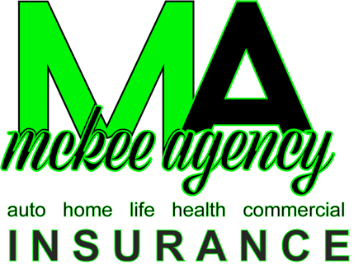

1400 S 5th St B
Leesville, LA 71446

For Immediate Release

Justin Bender
Jeb.av.productions@gmail.com
740-803-3323

Local insurance broker helping ease financial strain for small businesses

Leesville, LA, November 6 – McKee Agency, Your CHOICE for Insurance offers something different to their clients than your traditional insurance company. As an independent insurance broker, they search over 30 carriers to find the right coverage at a price that can be afforded. McKee Agency is rolling out new features to their business all with their customers in mind.

Jacob McKee, owner, returned to Vernon Parish to start McKee Agency, with the intention of treating every customer like family. During these past few years things have been trying for Louisianians from COVID to hurricanes. In this now post-pandemic environment small businesses and families are faced with exorbitant costs. The good news is there’s a glimmer of hope in this still dismal world. McKee Agency prides themselves in shopping your insurance needs with over 30 carriers to find you the exact coverage you need at a price you can afford. These savings will directly lower the bottom line needed for many local small businesses struggling to keep their lights on.

McKee Agency is rolling out new initiatives with their customers in mind. A new website will be unveiled, in the next quarter, focused on making customers’ experience with McKee Agency an easier one. McKee Agency is dedicated to making all their customers part of their family and are committed to service after the sale all the way through any claim that may arise.
###

McKee Agency, Your CHOICE For Insurance, an independent insurance broker located in Leesville, LA is committed to providing insurance solutions for their customers they can afford. You can like and follow them on Facebook at https://www.facebook.com/profile.php?id=100063718596139.

